SSKCloud Firmware Update Steps
We can update the firmware by computer(Web access), before updating, please make sure the Brower is as below:
Google Chrome
Fire fox
Safari
Doesn’t Support(Please don’t use):
IE Brower
360 Brower

Step 1

Computer connect to SSK Cloud wifi
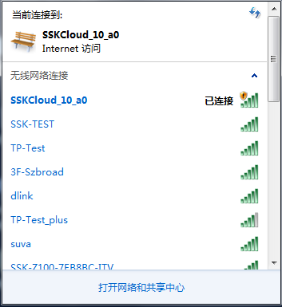

Step 2

Input in the browser:10.10.10.254

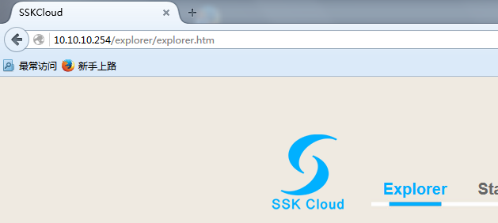

Step 3

After access, find System Module
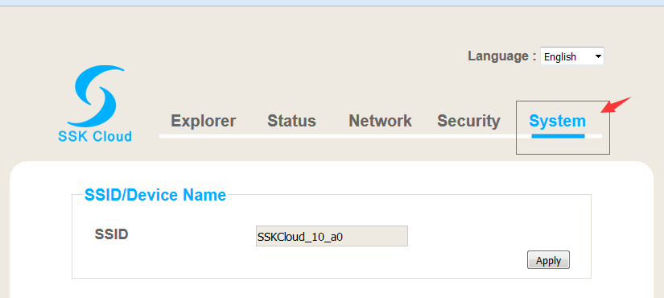

Step 4

Firmware upgrade, click Browse to select the update file
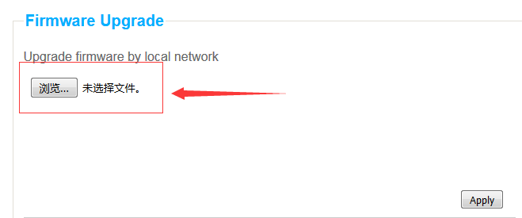

Step 5

Choose the Bin file
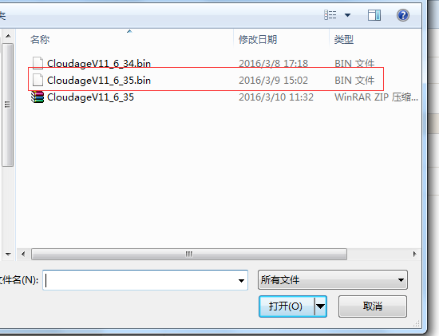

Step 6

Select bin file，click apply，then after success, click confirm.
