SSKCloud Firmware update Notice

In order to have a good experience, SSKCloud will be continued to update its firmware and app, to make sure your storage with the latest firmware, if App doesn’t prompt you to update the firmware automatically, please follow below steps to check and update the latest firmware by hand. Thank you.

How to check whether your storage with the latest firmware?
- Download SSKCloud App from App store or Google market;
- Mobile phone connect to sskcloud wifi hotspot;
- Click SSKCloud App, Settings---Help---Firmware Version, it shows storage firmware version is Cloudage V13_6_70
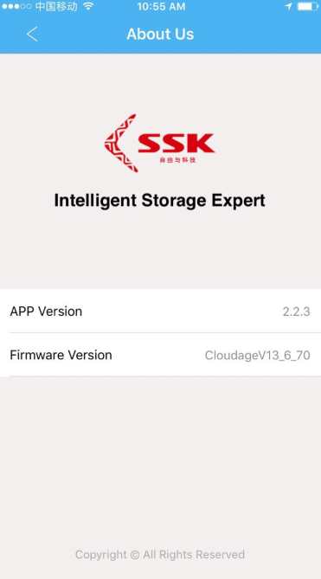
- Open SSK official English website: www.ssk.cn/en, enter ‘Support’;
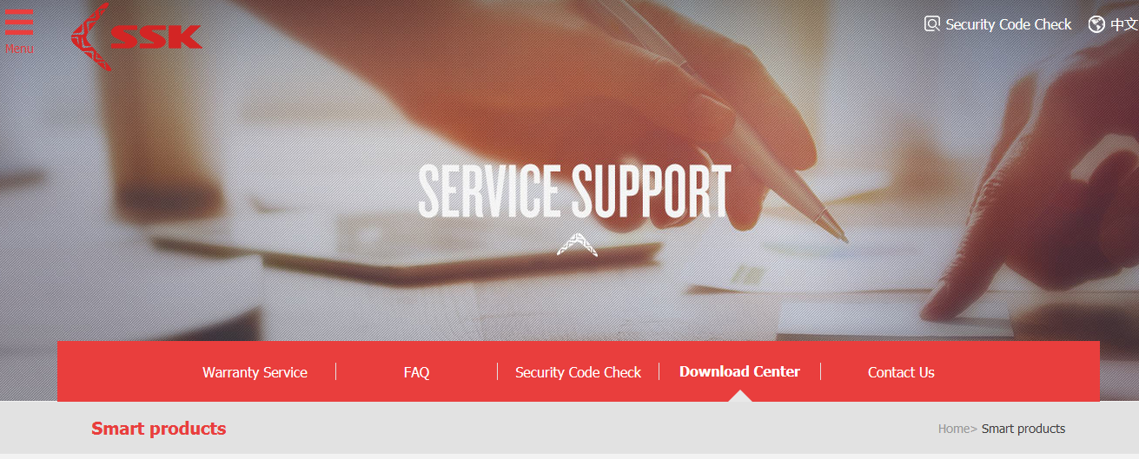
5. Click ‘Download Center’, you will find the relative firmware for different models(Please kindly noted V11 for F100, V13 for F200, and V10 for SW001)
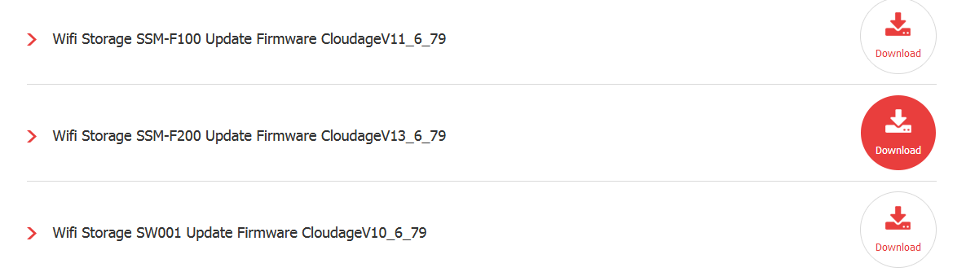

How to update your storage with the latest firmware?
- If your storage firmware is lower than the website firmware version, please download relative firmware and ‘SSKCloud firmware update step’ two files;
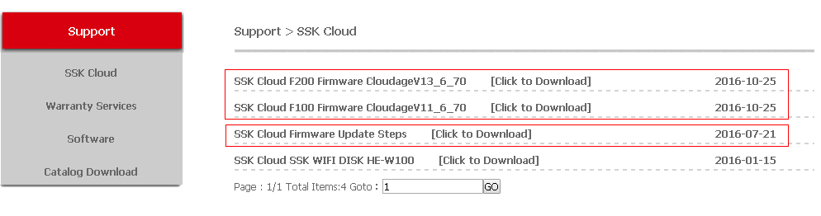
- Follow the ‘sskcloud firmware update steps’ to update your storage by computer accordingly (During the update, please do not power off the storage).
- After finished, you can check storage firmware version has updated to latest or not.

If you have any question or problem during the update, please contact us freely as below contact information. Thank you.
songjx@ssk.cn.

